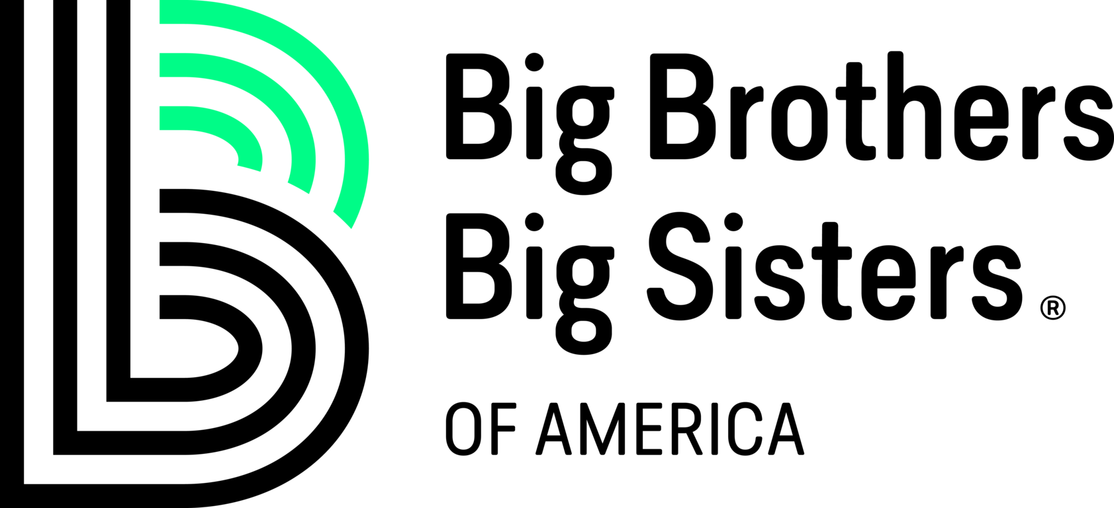
BIG BROTHER BIG SISTER DONATION RECEIPT

Date: __________________
Name of Non-Profit Organization: ___________________________
Mailing Address: ______________________________________________________

Donor Information
Donor’s Name: _______________________
­Donor’s Address: ________________________________________________________

Donation Information
Thank you for your donation with a value of ___________________________ Dollars ($_____________), made to the above-mentioned 501(c)(3) Non-Profit Organization.
Donation Description: ________________________________________________________
__________________________________________________________________________

I, the undersigned representative, declare (or certify, verify, or state) under penalty of perjury under the laws of the United States of America that there were no goods or services provided as part of this donation. Furthermore, as of the date of this receipt the above-mentioned organization is a current and valid 501(c)(3) non-profit organization in accordance with the standards and regulations of the Internal Revenue Service (IRS).

Representative’s Signature ___________________________
Representative’s Name ___________________________
Title: _________________________ Date: __________________

